**ES 216 Signals, Systems and Networks**

**Programming Assignment 2**

**Name:** Girish Chandar G

**Roll No:** 16110057

**Discipline:** Electrical Engineering

**Aim:**

Detection of QRS complexes and calculation of heart rates from a given ECG signals.

**Theory:**

Power Spectrum of ECG signal provides useful information about the QRS complex. Often the signal contains P and T waves, EMG from muscles, motion artifact from electrode and skin interface and other interferences from electro surgery equipments. Clinical Instruments such as arrhythmia monitor require real-time QRS detection. Therefore it is necessary to extract useful part of the signal, the QRS complex, from the other noises such as P and T waves, motion artifact and muscle noise.

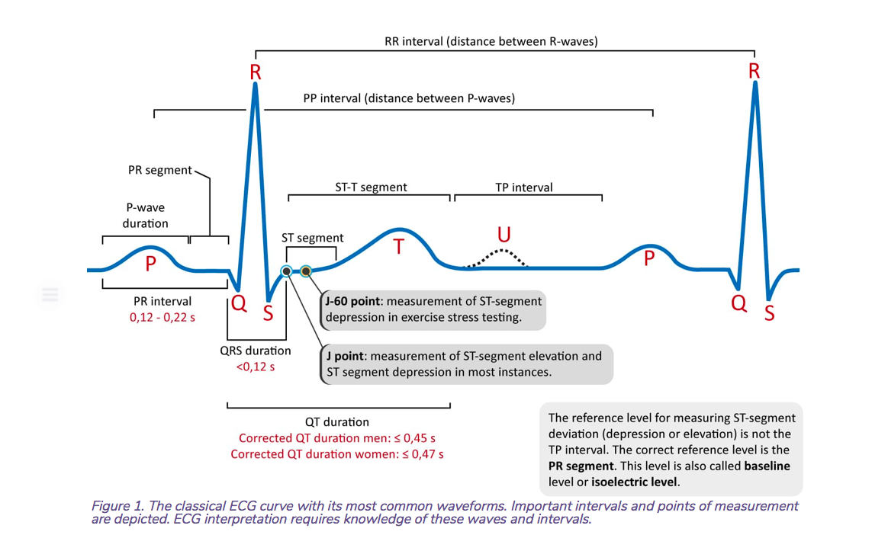

**Procedure:**

The following procedures is followed to extract the necessary information from a given ECG signal

* BandPass Filter:
  + First the ECG signal is passed through a band pass filter, composed of cascaded low pass and high pass filter. Passband is 5 – 12 Hz.
  + This is done to attenuate noise.
* Derivative:
  + Then the output of the band pass signal is passed is differentiated.
  + This is done to obtain information of the slope of the signal.
* Squaring:
  + Intensifies the slope of the frequency response curve.
  + Restricts the false positives caused by the T waves
* Moving window Integration
  + Provides information of about both the slope and the width of the QRS complex
* Threshold
  + Optimum threshold is chosen to find all the peaks and no of beats accurately

**Results:**

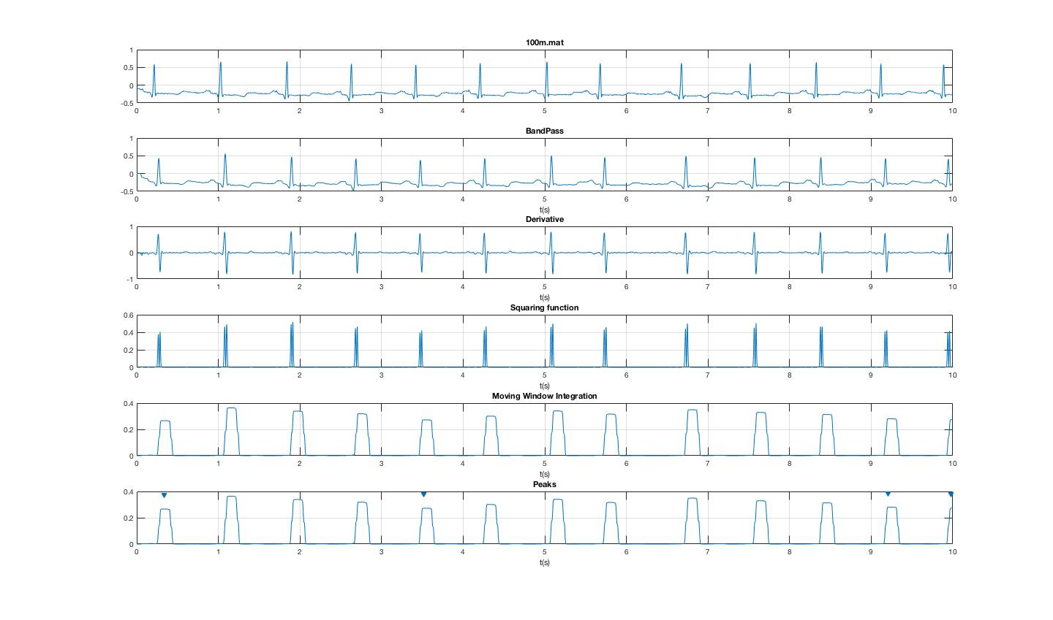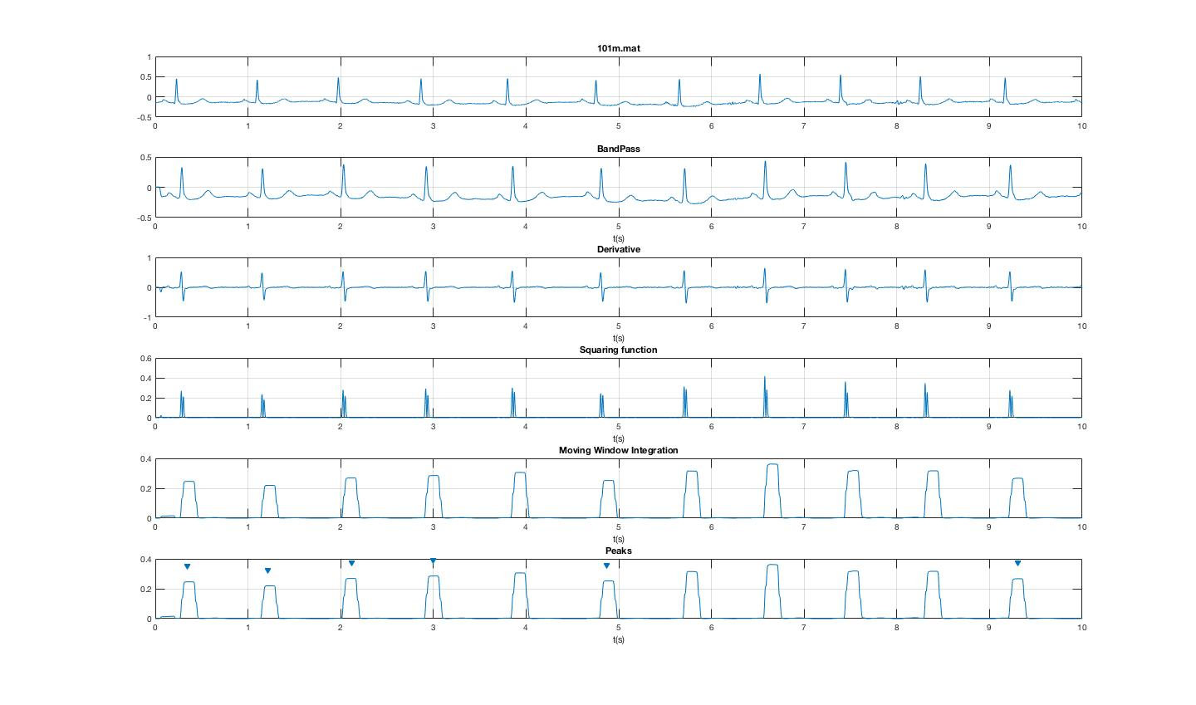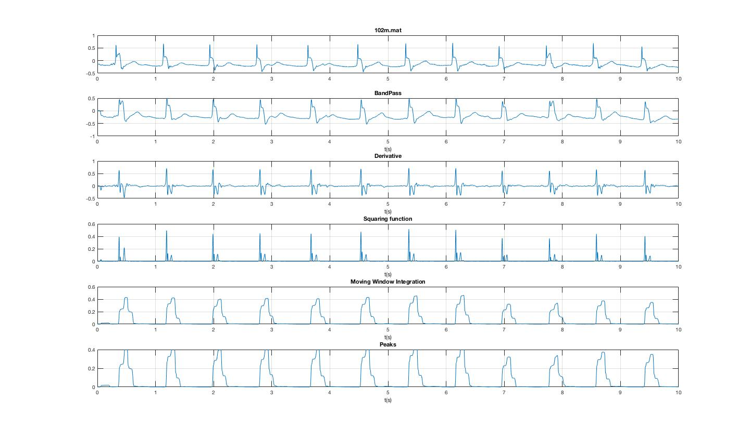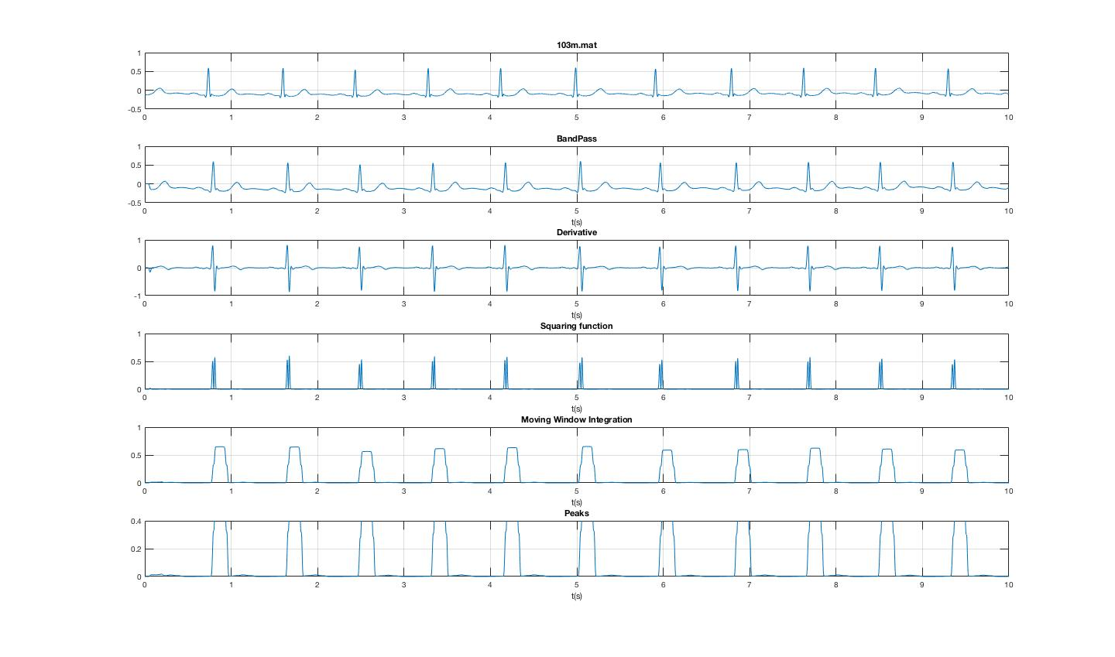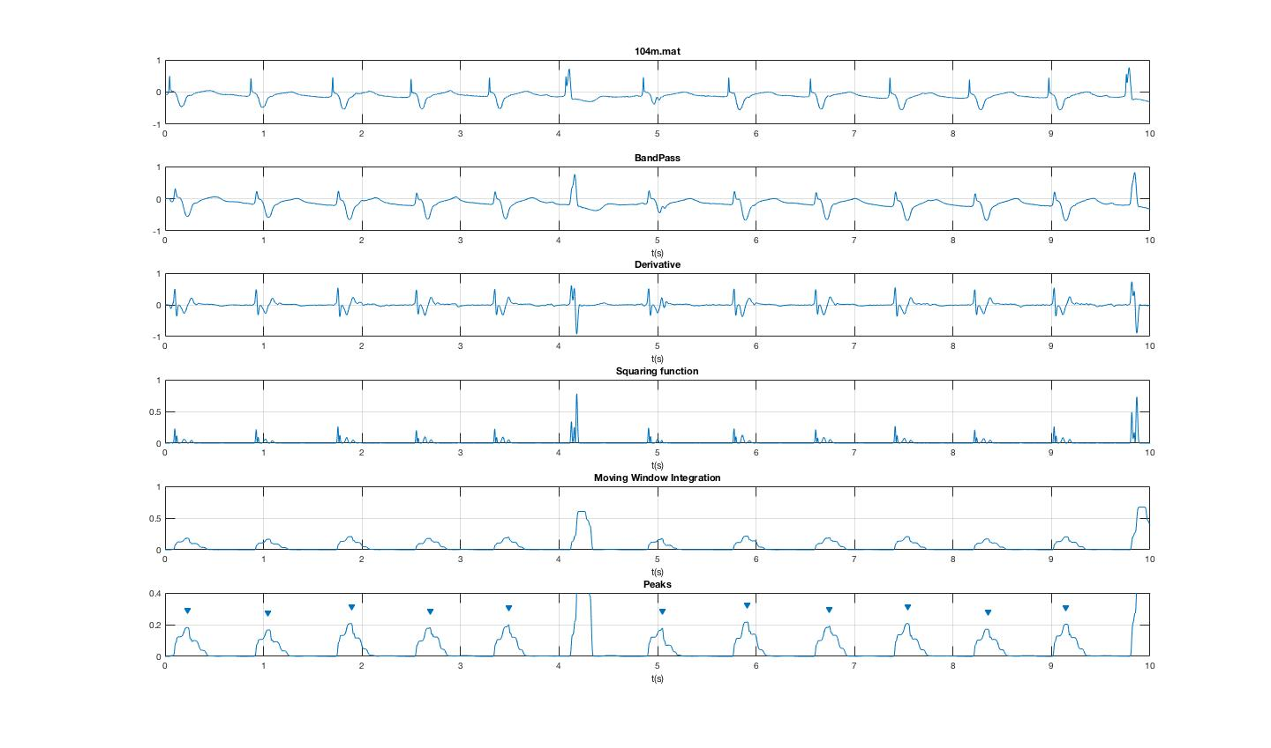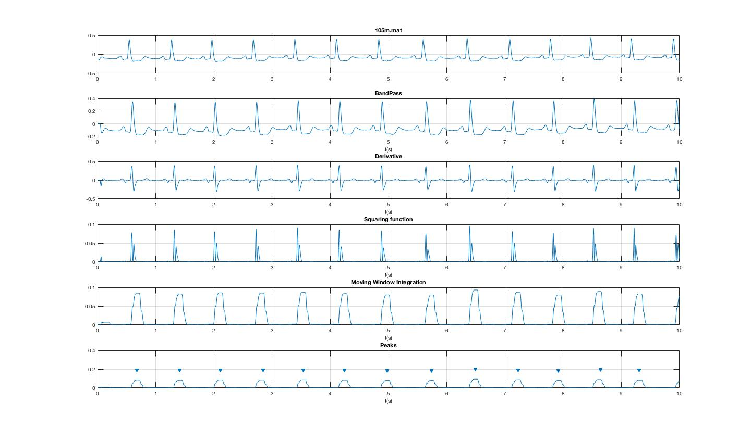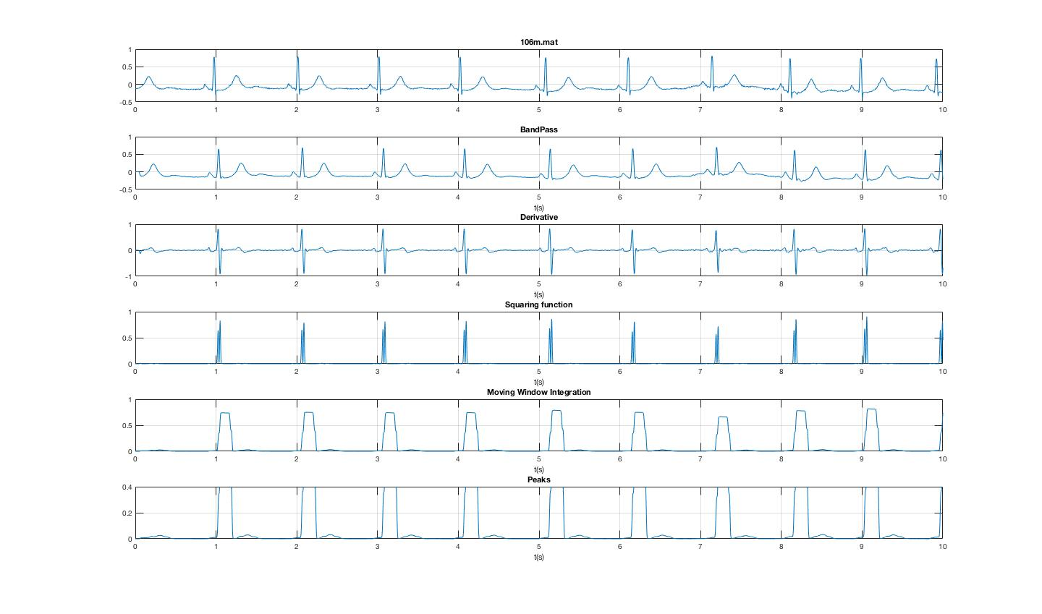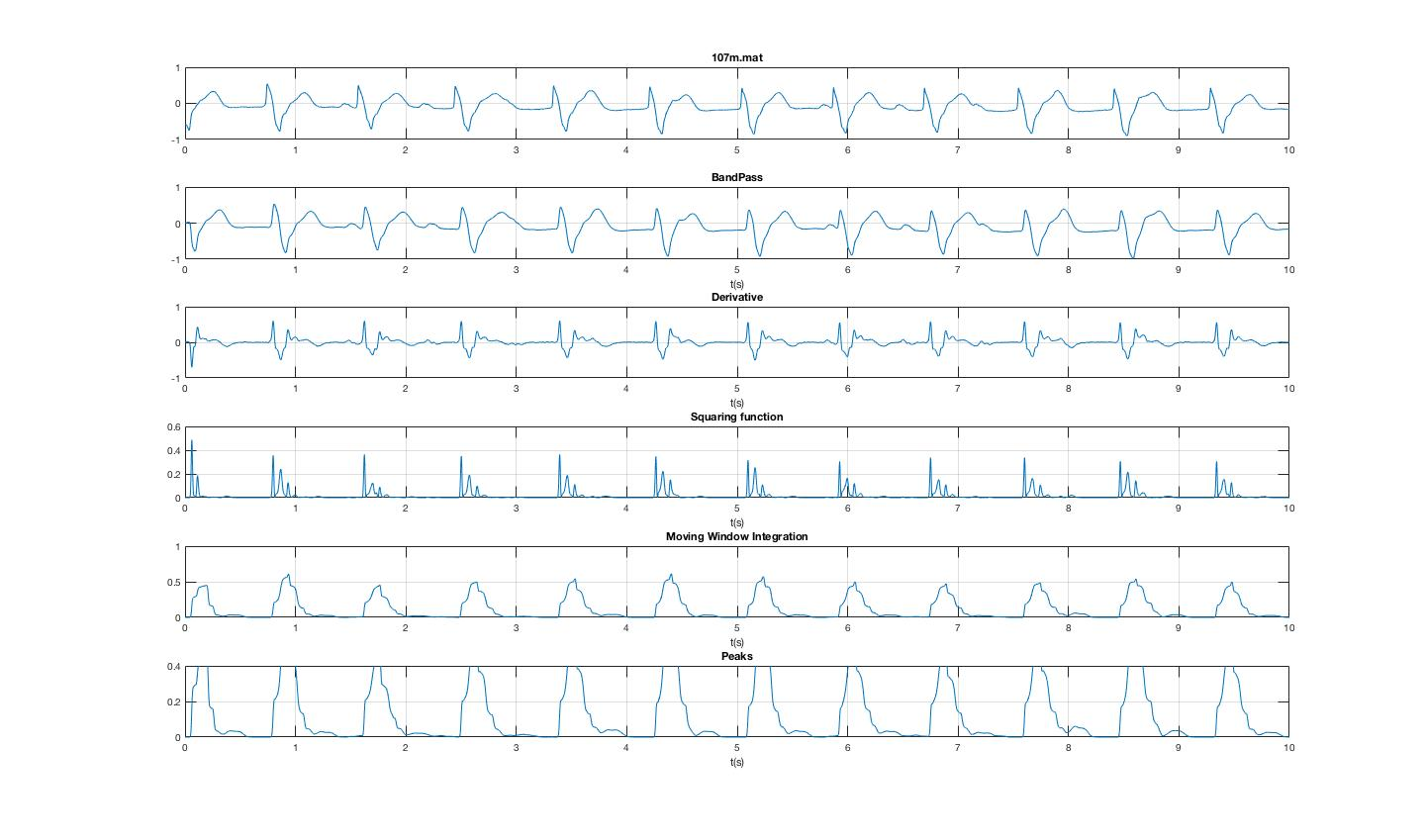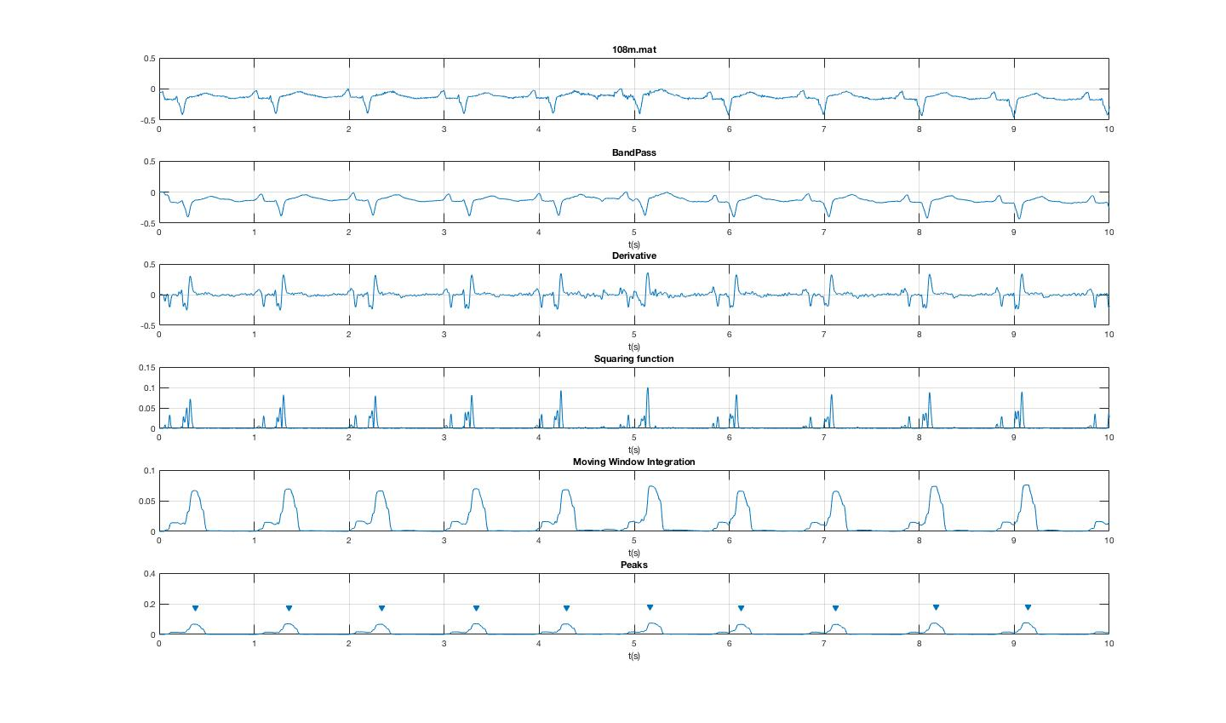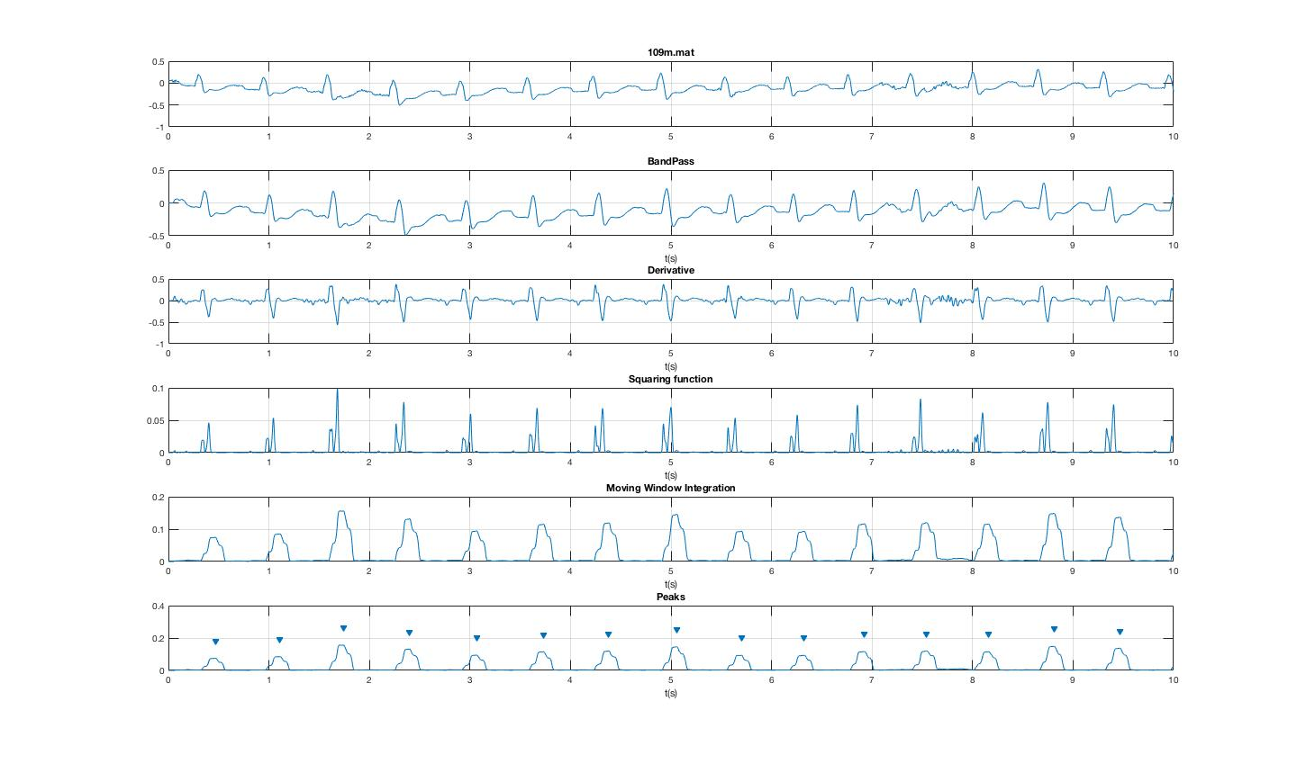

**Calculation:**

Data No of Beats Beats per minute

100m.mat 2273 75.541914

101m.mat 1874 62.272271

102m.mat 2187 72.671978

103m.mat 2084 69.261249

104m.mat 2387 79.306307

105m.mat 2664 88.554982

106m.mat 2068 68.747758

107m.mat 2606 86.600528

108m.mat 1850 61.474240

109m.mat 2533 84.163615

**References:**

* <https://ecgwaves.com/ecg-normal-p-wave-qrs-complex-st-segment-t-wave-j-point/>
* Jiapu Pan et.al, “A Real Time QRS detection Algorithm”, IEEE TRANSACTIONS ON BIOMEDICAL ENGINEERING, VOL. BME-32, NO. 3, MARCH 1985. <https://ieeexplore.ieee.org/abstract/document/4122029/>
* Valtino X.Alfonso, “ECG QRS Detection”, <https://www.ejwoo.com/uploads/2/5/4/0/25400517/ecg_qrs_detection.pdf>
* <https://in.mathworks.com/help/signal/examples/peak-analysis.html>